# Lab 08 - Manage Virtual Machines

Made by Valeriy Manuilyk <3

## Task 1: Deploy zone-resilient Azure virtual machines by using the Azure portal

1.Sign in to the Azure portal - https://portal.azure.com.

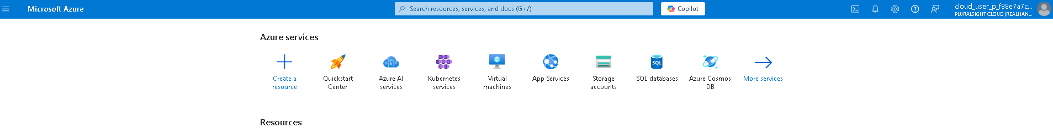

2.Search for and select Virtual machines, on the ****Virtual machines**** blade, click ****+ Create****, and then select in the drop-down ****Azure virtual machine****. Notice your other choices.

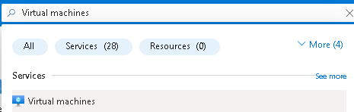

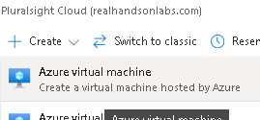

3.On the ****Basics**** tab, in the ****Availability zone**** drop down menu, place a checkmark next to ****Zone 2****. This should select both ****Zone 1**** and ****Zone 2****.

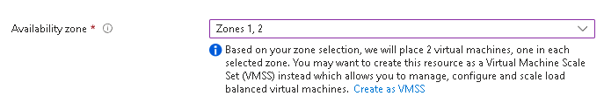

4.On the Basics tab, continue completing the configuration:

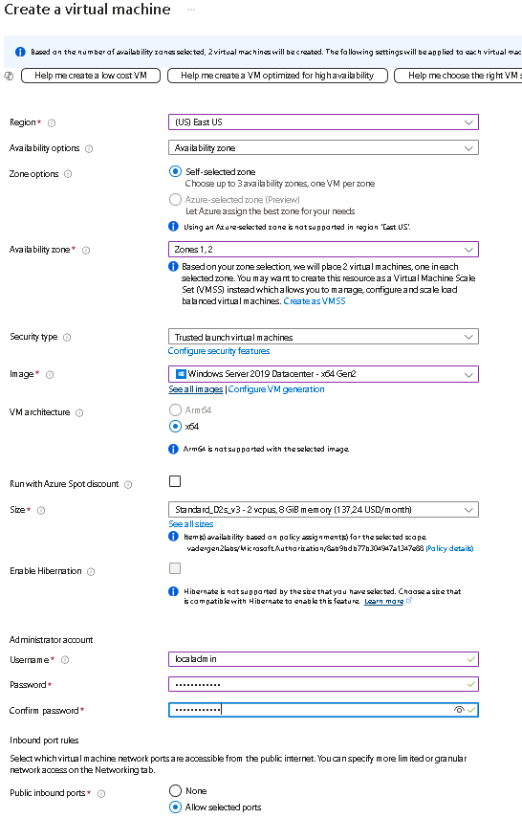

5.Click ****Next : Disks >**** , specify the following settings (leave others with their default values):

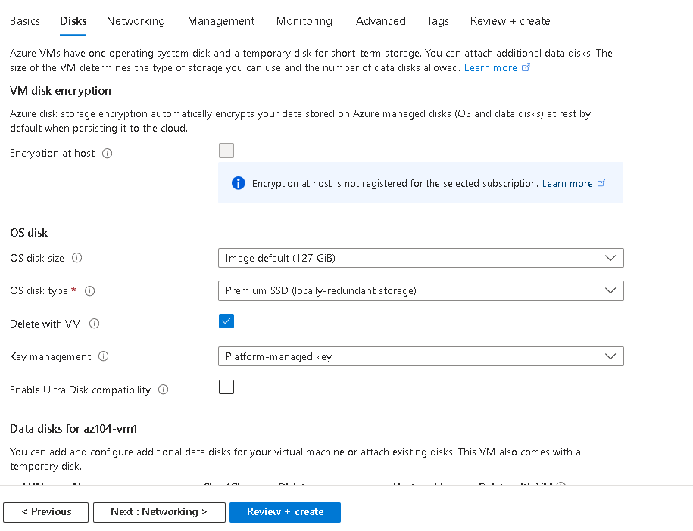

6.Click ****Next : Networking >**** take the defaults but do not provide a load balancer.

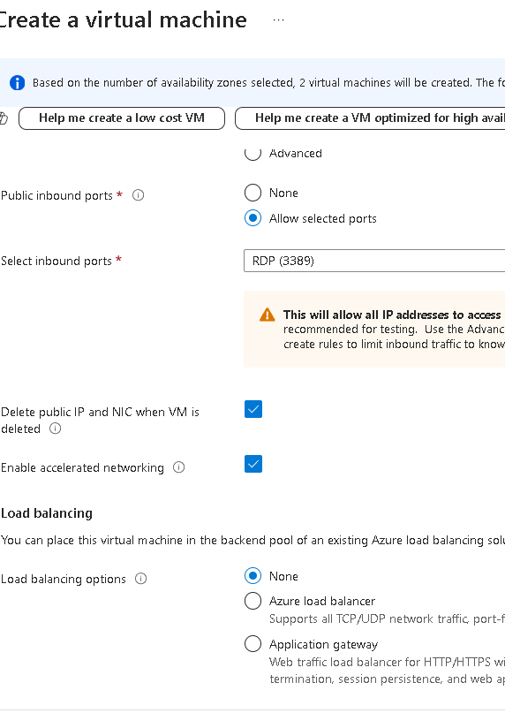

7.Click ****Next : Management >**** and specify the following settings (leave others with their default values):

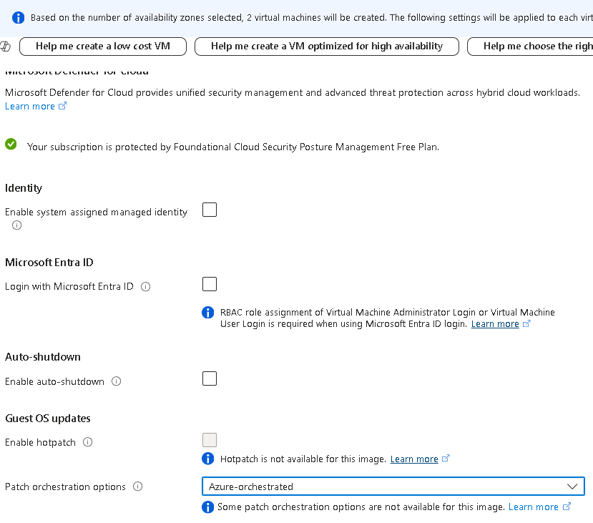

8.Click ****Next : Monitoring >**** and specify the following settings (leave others with their default values):

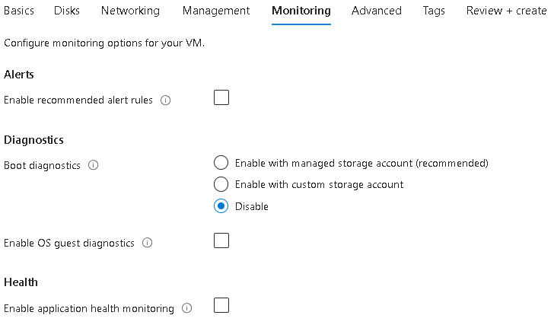

9.Click ****Next : Advanced >****, take the defaults, then click ****Review + Create****.

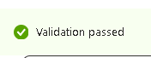

10.After the validation, click ****Create****.

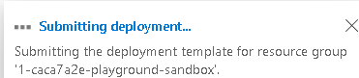

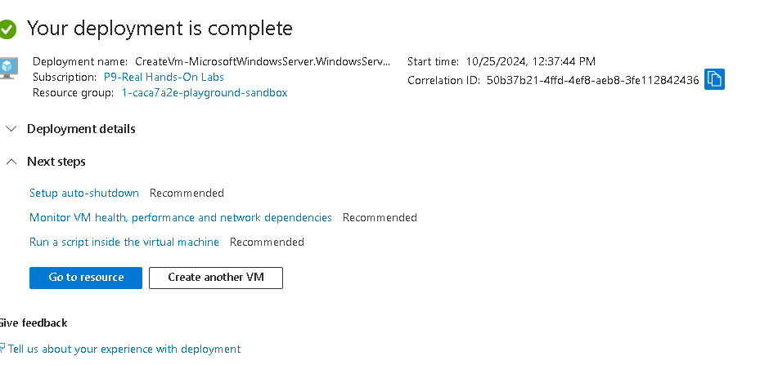

## Task 2: Manage compute and storage scaling for virtual machines

1.On the ****az104-vm1**** virtual machine, in the ****Availability + scale**** blade, select ****Size****.

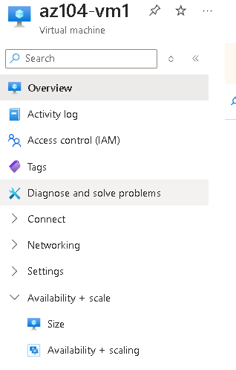

2.Set the virtual machine size to ****DS1_v2**** and click ****Resize****. When prompted, confirm the change.

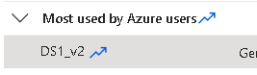

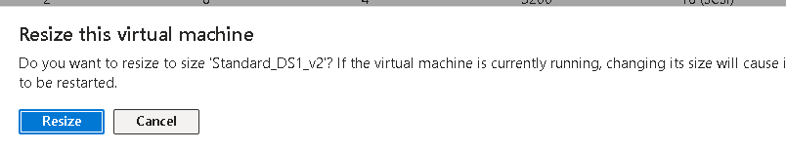

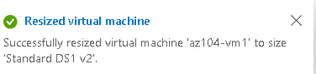

3.In the ****Settings**** area, select ****Disks****.

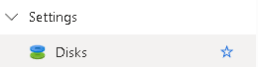

4.Under ****Data disks**** select ****+ Create and attach a new disk****. Configure the settings (leave other settings at their default values).

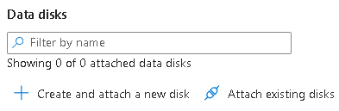

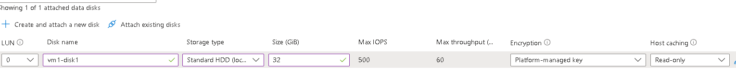

5.Click ****Apply****.



6.After the disk has been created, click ****Detach**** (if necessary, scroll to the right to view the detach icon), and then click ****Apply****.



7.Search for and select Disks. From the list of disks, select the ****vm1-disk1**** object.

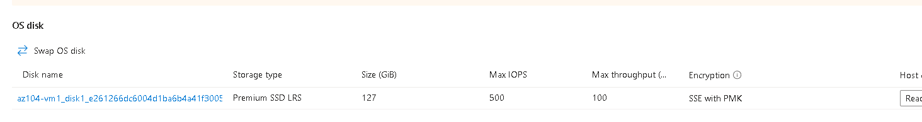

1. In the ****Settings**** blade, select ****Size + performance****.

9.Set the storage type to ****Standard SSD****, and then click ****Save****.

10.Navigate back to the ****az104-vm1**** virtual machine and select ****Disks****.

11.In the ****Data disk**** section, select ****Attach existing disks****.

12.In the ****Disk name**** drop-down, select ****VM1-DISK1****.

13.Verify the disk is now ****Standard SSD****.

14.Select ****Apply**** to save your changes.

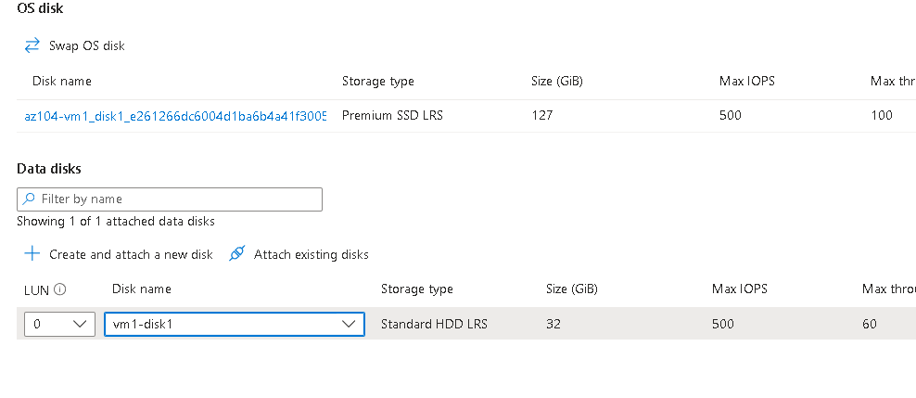

## Task 3: Create and configure Azure Virtual Machine Scale Sets

1.In the Azure portal, search for and select Virtual machine scale sets and, on the ****Virtual machine scale sets**** blade, click ****+ Create****.

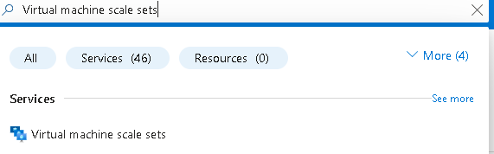

2.On the ****Basics**** tab of the ****Create a virtual machine scale set**** blade, specify the following settings (leave others with their default values) and click ****Next : Spot >****:

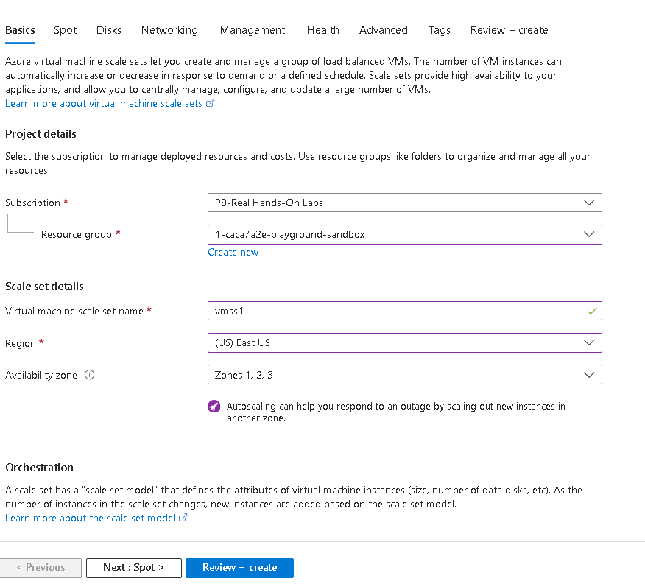

3.On the ****Spot**** tab, accept the defaults and select ****Next : Disks >****.

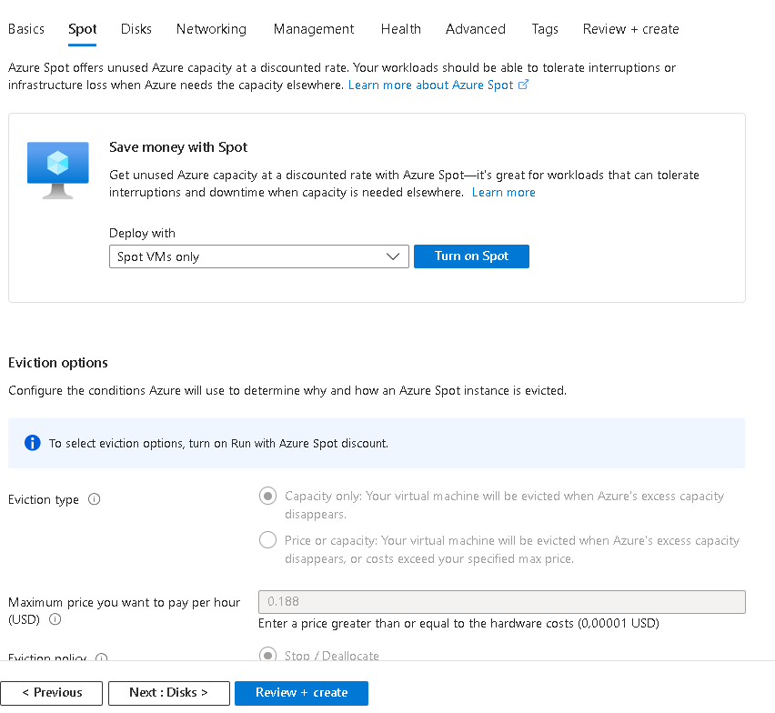



4.On the ****Disks**** tab, accept the default values and click ****Next : Networking >****.

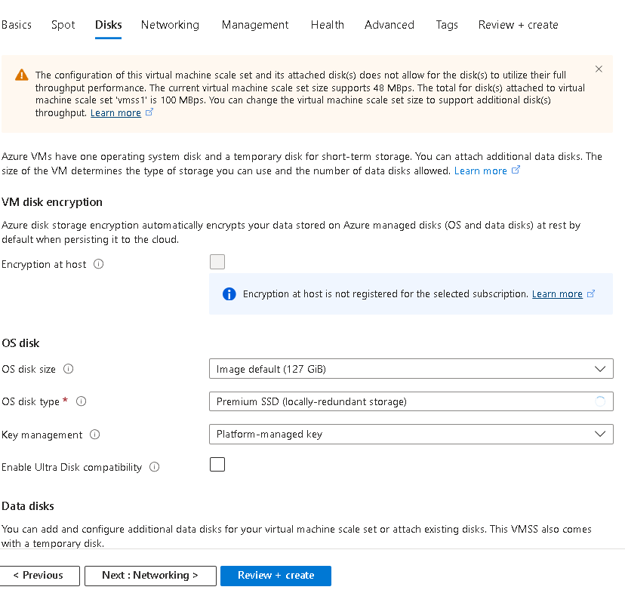

4.On the ****Disks**** tab, accept the default values and click ****Next : Networking >****.

5.On the ****Networking**** page, click the ****Create virtual network**** link below the ****Virtual network**** textbox and create a new virtual network with the following settings (leave others with their default values). When finished, select ****OK****.

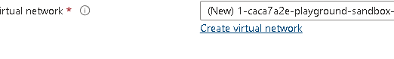

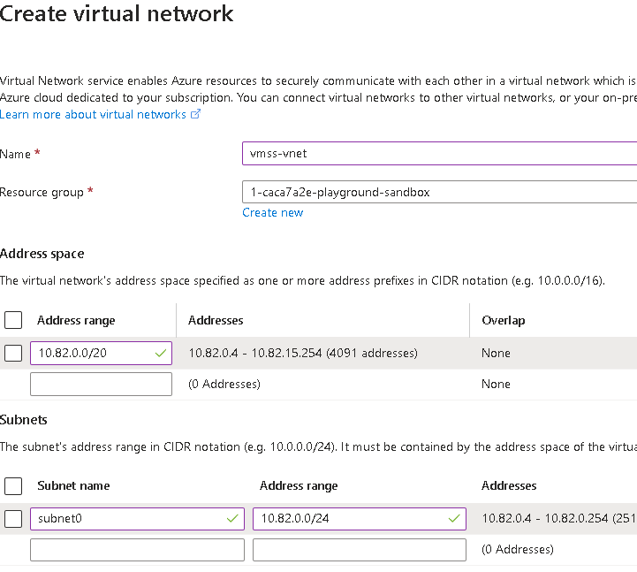

6.In the ****Networking**** tab, click the ****Edit network interface**** icon to the right of the network interface entry.

7.For ****NIC network security group**** section, select ****Advanced**** and then click ****Create new**** under the ****Configure network security group**** drop-down list.

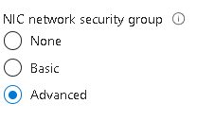

8.On the ****Create network security group**** blade, specify the following settings (leave others with their default values):

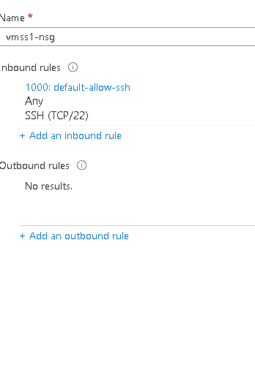

9.Click ****Add an inbound rule**** and add an inbound security rule with the following settings (leave others with their default values):

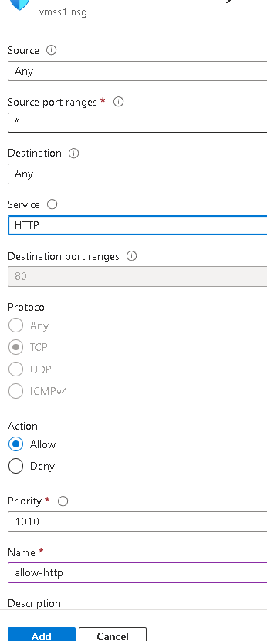

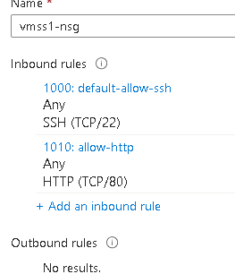

10.Click ****Add**** and, back on the ****Create network security group**** blade, click ****OK****.

11.In the ****Networking**** tab, under the ****Load balancing**** section, specify the following (leave others with their default values).

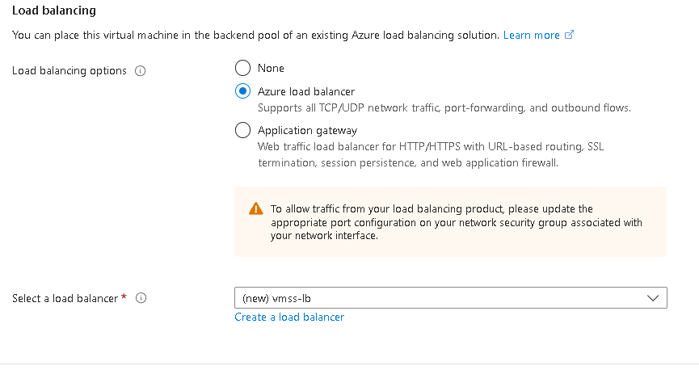

12.On the ****Management**** tab, specify the following settings (leave others with their default values):

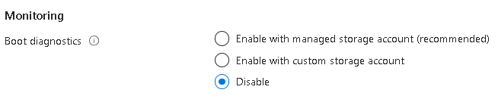

13.Click ****Next : Health >****.



14.On the ****Health**** tab, review the default settings without making any changes and click ****Next : Advanced >****.

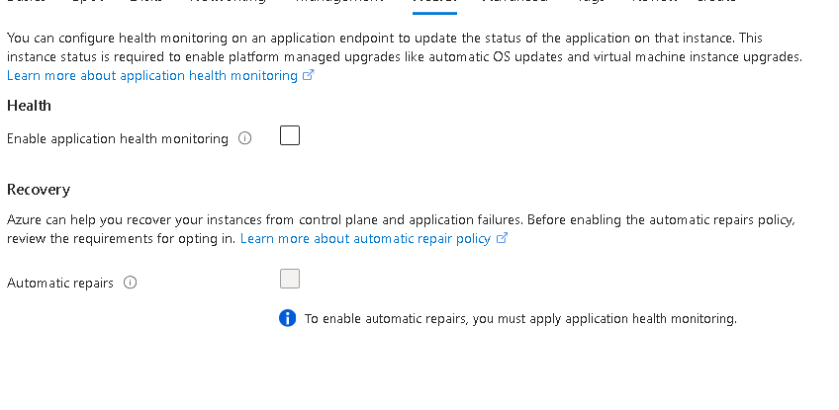

15.On the ****Advanced**** tab, click ****Review + create****.

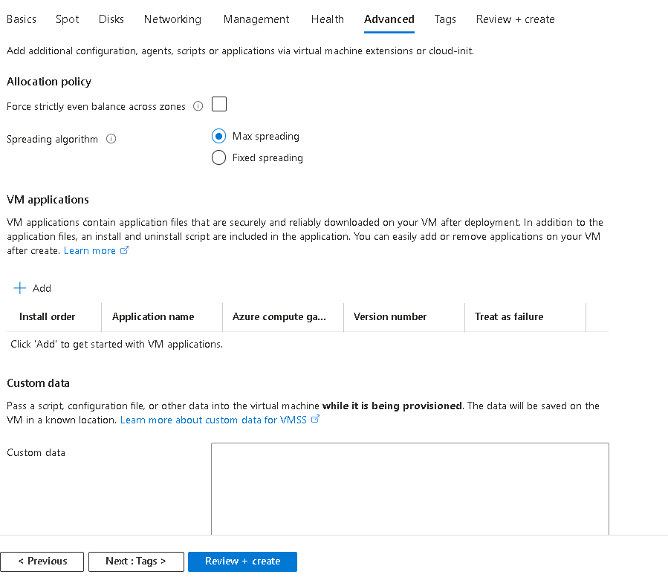

16.On the ****Review + create**** tab, ensure that the validation passed and click ****Create****.

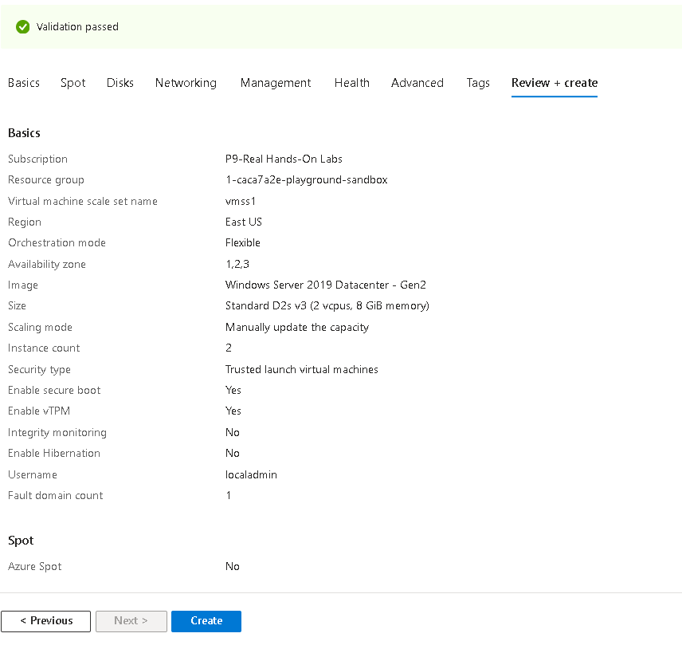

## Task 4: Scale Azure Virtual Machine Scale Sets

1.Select ****Go to resource**** or search for and select the ****vmss1**** scale set.

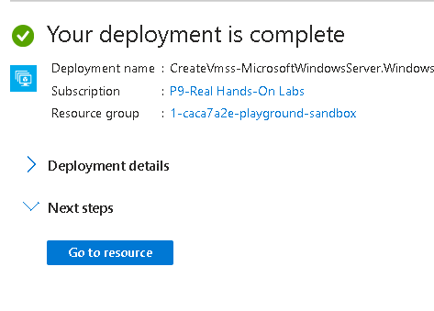

2.Choose ****Availability + Scaling**** from the left side menu, then choose ****Scaling****.

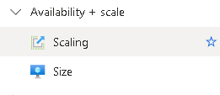

### Scale out rule

1.Select ****Custom autoscale****. Then change the ****Scale mode**** to ****Scale based on metric****. And then select ****Add a rule****.

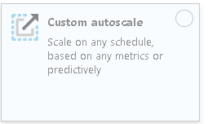

2.Let’s create a rule that automatically increases the number of VM instances. This rule scales out when the average CPU load is greater than 70% over a 10-minute period. When the rule triggers, the number of VM instances is increased by 20%.

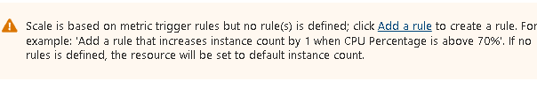

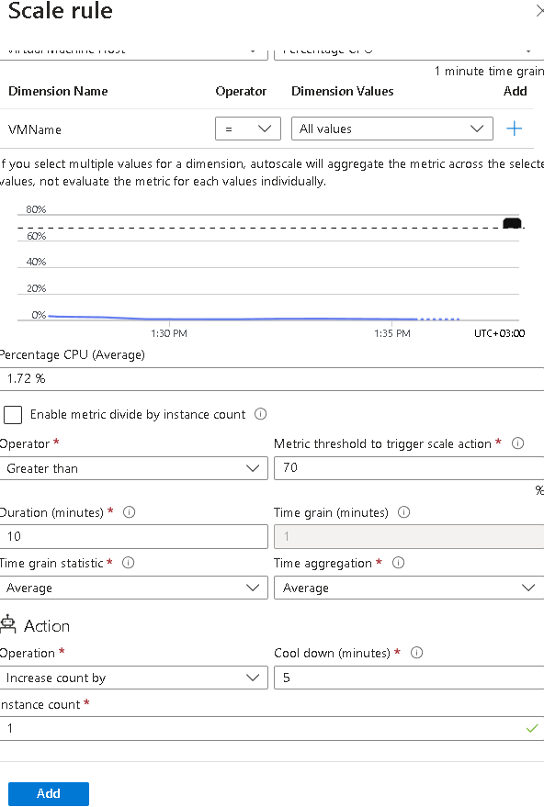

3.Be sure to ****Save**** your changes.



### Scale in rule

1.During evenings or weekends, demand may decrease so it is important to create a scale in rule.

2.Let’s create a rule that decreases the number of VM instances in a scale set. The number of instances should decrease when the average CPU load drops below 30% over a 10-minute period. When the rule triggers, the number of VM instances is decreased by 20%.

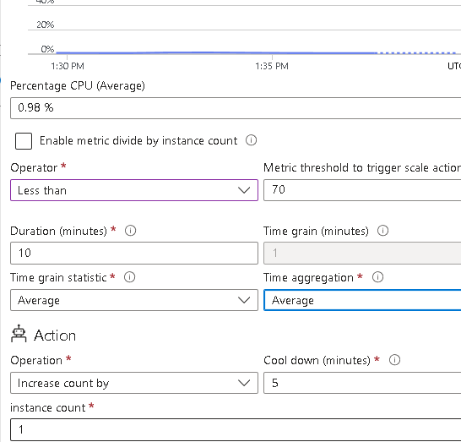

3.Select ****Add a rule****, adjust the settings, then select ****Add****.

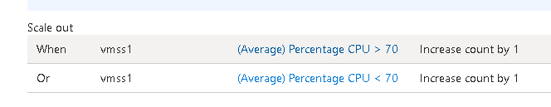

4.Be sure to ****Save**** your changes.



### Set the instance limits

1.When your autoscale rules are applied, instance limits make sure that you do not scale out beyond the maximum number of instances or scale in beyond the minimum number of instances.



**2.**Instance limits**** are shown on the ****Scaling**** page after the rules.

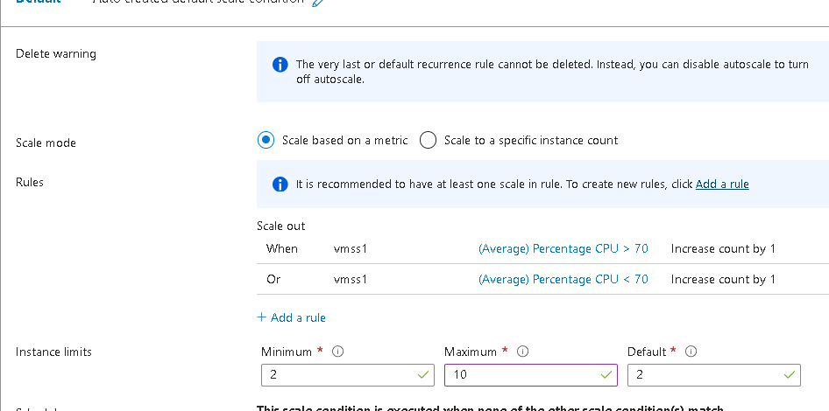

3.Be sure to ****Save**** your changes

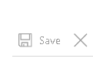

4.On the ****vmss1**** page, select ****Instances****. This is where you would monitor the number of virtual machine instances.

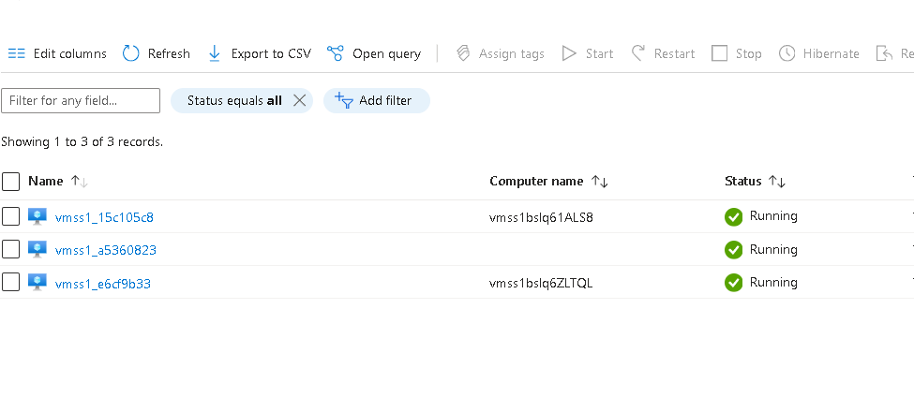

## Task 5: Create a virtual machine using Azure PowerShell (option 1)

1.Use the icon (top right) to launch a ****Cloud Shell**** session. Alternately, navigate directly to https://shell.azure.com.

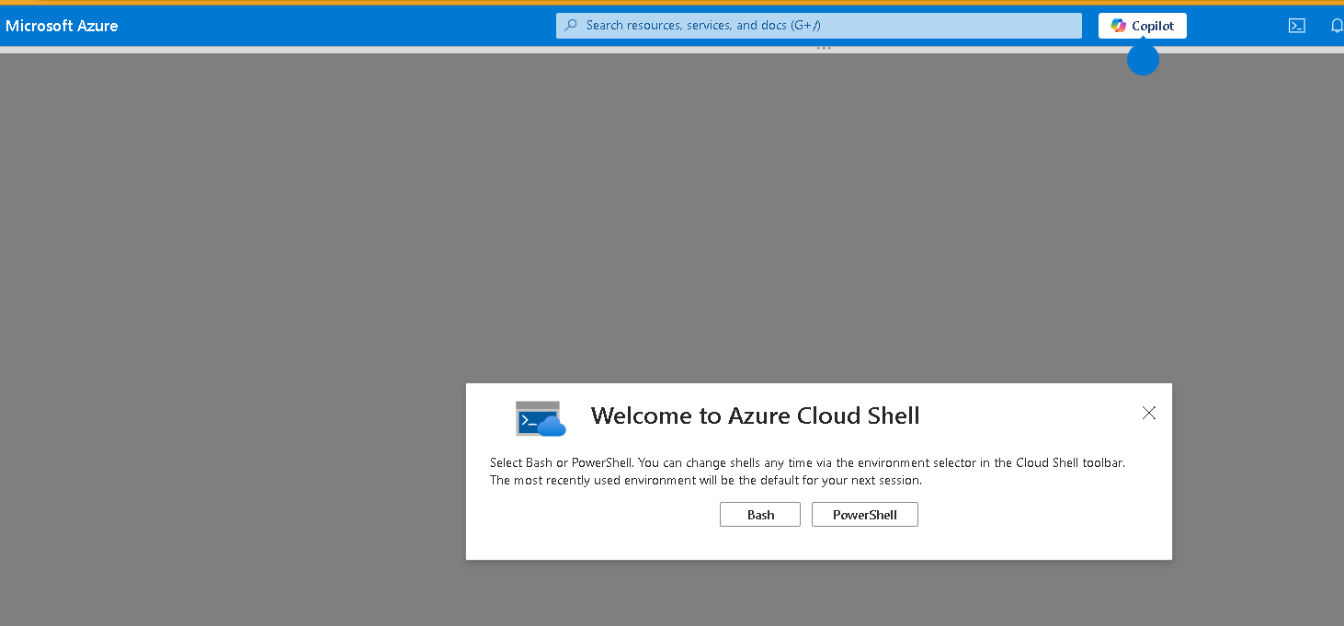

2.Be sure to select ****PowerShell****. If necessary, configure the shell storage.

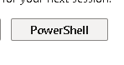

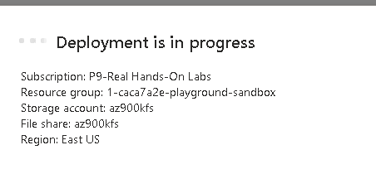

3.Run the following command to create a virtual machine. When prompted, provide a username and password for the VM. While you wait check out the [New-AzVM](https://learn.microsoft.com/powershell/module/az.compute/new-azvm?view=azps-11.1.0) command reference for all the parameters associated with creating a virtual machine.

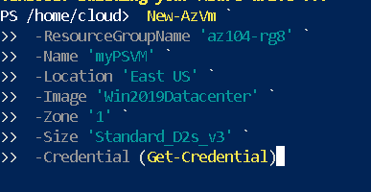

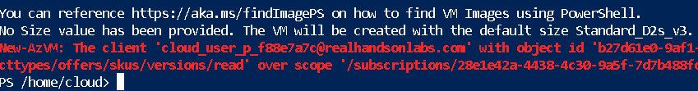

**Conclusion:**

Azure virtual machines are on-demand, scalable computing resources.

Azure virtual machines provide both vertical and horizontal scaling options.

Configuring Azure virtual machines includes choosing an operating system, size, storage and networking settings.

Azure Virtual Machine Scale Sets let you create and manage a group of load balanced VMs.

The virtual machines in a Virtual Machine Scale Set are created from the same image and configuration.

In a Virtual Machine Scale Set the number of VM instances can automatically increase or decrease in response to demand or a defined schedule.